Customer Journey Map
Date | 30 September 2026
Team ID | SWTID-2026-3379
Project Name | AI Weather Wise
Team Size | 4
Team Leader | PREETHI L
Team Members | DEVI PRIYA S, SUMITHRA G, SIPORAL U
Maximum Marks | 2 Marks

Customer Journey Map
The map follows a student or daily commuter through the complete experience of using AI Weather Wise, from searching for a location to acting on the weather guidance. For each stage it records the customer's actions, touchpoints, thoughts and feelings, along with process ownership (using the team's proposed roles) and improvement opportunities.
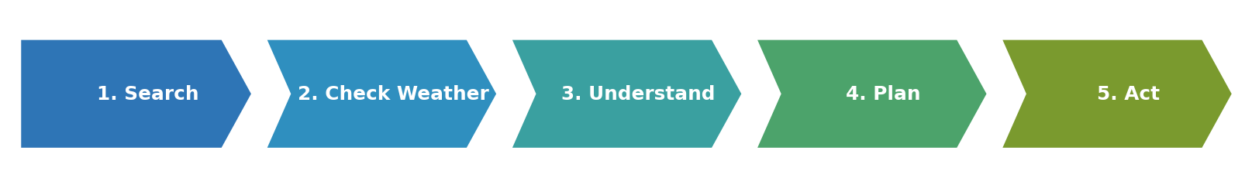
Figure 1: Customer journey stages - Search, Check Weather, Understand, Plan, Act
Phase of Journey | Stage 1: Search | Stage 2: Check Weather | Stage 3: Understand Weather | Stage 4: Plan | Stage 5: Act
Actions  What does the customer do? | - Opens the application  - Types a city / area name  - Presses search | - Views current temperature and condition  - Looks at the forecast  - Checks rain / wind details | - Reads the weather summary  - Reads the weather advice  - Notes any warning message | - Decides what to wear or carry  - Chooses travel time or activity  - Compares with the forecast | - Carries umbrella / suitable clothing  - Travels or continues activity  - Returns later to re-check
Touchpoint  What part of the service do they interact with? | - Location search box  - Search button  - Error message (if location is invalid) | - Current weather card  - Forecast section  - Loading indicator | - Guidance panel  - Icons and simple text  - Warning messages | - Forecast details  - Guidance panel | - Application re-opened on phone / laptop  - Refreshed weather result
Customer Thought  What is the customer thinking? | - "I hope it finds my area quickly."  - "Is my location spelt correctly?" | - "Will it rain today?"  - "Can I trust this forecast?" | - "What does this mean for me?"  - "Is this simple enough to understand?" | - "Should I carry an umbrella?"  - "How will this affect my travel?" | - "I am prepared for the weather."  - "Let me check again before I return."
Customer Feeling  What is the customer feeling? | Hopeful, slightly impatient | Concerned about sudden changes | Confident if clear; frustrated if confusing | Reassured and in control | Safer and better prepared
Process Ownership  Who is in the lead on this? | SUMITHRA G (search interface)  DEVI PRIYA S (input handling) | DEVI PRIYA S (API / data)  SUMITHRA G (weather display) | SIPORAL U (guidance logic)  SUMITHRA G (presentation) | SIPORAL U (guidance rules)  PREETHI L (coordination) | PREETHI L (testing coordination and feedback)  Whole team (improvements)
Opportunities  How can we improve this stage? | - Auto-suggest city names  - Optional use of device location (future)  - Remember last searched location (future) | - Faster loading  - Clear units and time of update  - Hourly view (future) | - Plain-language summary  - Icons for rain / sun / wind  - Explain why advice is given | - Activity-based advice (future)  - Multi-day planning view | - Weather alerts / notifications (future)  - Saved locations (future)  - Feedback option

Note: Opportunities marked (future) are ideas for later versions and are not claimed as implemented features.

